PANDAS

**What is Pandas**?

Pandas is a Python library used for working with data sets.

It has functions for analyzing, cleaning, exploring, and manipulating data.

**Why Use Pandas?**

Pandas allows us to analyze big data and make conclusions based on statistical theories.

Pandas can clean messy data sets, and make them readable and relevant data.

**#Syntax --> pandas.Series(data=None, index=None, dt ype=None, name=None, copy=True or False)**

**#E.g-1**

**import** pandas **as** pd pd.Series(my_data)

1. 10
2. 20
3. 30

dtype: int64

type(pd.Series(my_data)) pandas.core.series.Series

**#Series with labels**

pd.Series(data**=**my_data, index**=**labels)

**# or**

pd.Series(my_data, labels)

a 10 b 20 c 30 dtype: int64

pd.Series(data**=**[print, len, sum])

1. <built-in function print>
2. <built-in function len> 2 <built-in function sum> dtype: object

**#*decorator:******Pandas does provide a concept called "dec orators" in the form of DataFrame/Series accessor functions.***

***Accessors in Pandas are used to provide access to addi tional methods and attributes that are not directly ava ilable on DataFrame or Series objects. They allow you to extend the functionality of Pandas objects by defini ng custom methods that can be accessed through a spe cial syntax.***

**def** decor(func): **def** inner(): str1 **=** func() **return** str1.upper() **return** inner

@decor

**def** greet(): **return** "good morning" print(greet())

GOOD MORNING

ser1 **=** pd.Series([1,2,3,4,5],["USA","India","Canada","UK","

Egypt"])

ser1

USA 1

India 2

Canada 3

UK 4 Egypt 5

dtype: int64

**#access values using index**

ser1[0:3]

USA 1

India 2

Canada 3

dtype: int64

ser2 **=** pd.Series([5,6,7,8],["USA","Brazil","Canada","UK"]) ser1**+**ser2

Brazil NaN

Canada 10.0

Egypt NaN

India NaN

UK 12.0 USA 6.0 dtype: float64

**# To create a new data in series** ser2['china'] **=** 'duplicate' ser2

USA 5

Brazil 6

Canada 7 UK 8 china duplicate dtype: object

**#*Dataframe: DataFrame is a two-dimensional labeled data structure that is widely used for data manipulatio n and analysis. It is essentially a table with rows and c olumns, where each* *column can have a different data t ype (e.g., integer, float, string, etc.).***

***#pd.DataFrame(datas, row_label, col_label)***

df **=** pd.DataFrame(np.random.randn(5,4)) df

# 0 1 2 3

**0**

-

0.743617

0.043163

1.257809

-

0.441337

**1** -0.634113 -0.099980 2.282786 -0.816584

**2**

0.166242

-

0.432571

-

1.512663

-

0.235004

# 0 1 2 3

**3** -0.695917 1.006487 0.154597 -1.137518

**4**

0.715899

0.261169

-

0.065419

-

1.069397

df **=** pd.DataFrame(np.random.randn(5,4), ['A','B','C','D','E'

],['w','x','y','z']) df

# w x y z

**A**

-

1.390346

-

0.617943

-

0.235332

1.834664

**B** 0.776284 -2.006753 -1.595141 0.525834

**C**

0.044868

-

0.131634

-

0.026057

-

0.599927

**D** -1.316303 0.486794 -0.961434 -1.379597

|  |  |  |
| --- | --- | --- |
| **E** | 0.456750 -1.923114 -0.885952 | 0.328777 |

**# To convert dictionary to DataFrame**

d **=** {"col1":[1,2], "col2":[3,40], "col3":[5,6]} print(d)

df **=** pd.DataFrame(d, ['row1','row2'])

print("\n",df)

{'col1': [1, 2], 'col2': [3, 40], 'col3':

[5, 6]}

col1 col2 col3 row1 1 3 5 row2 2 40 6 **#Transpose**

df.T

**A B C D E**

|  |  |  |  |  |
| --- | --- | --- | --- | --- |
| **w**  1.390346 | 0.776284 | 0.044868 | -  1.316303 | 0.456750 |
| **x**  0.617943 |  |  | 0.486794 | -  1.923114 |
| **y**  0.235332 | 1.595141 | 0.026057 | - | 0.885952 |

**z** 1.834664 0.525834 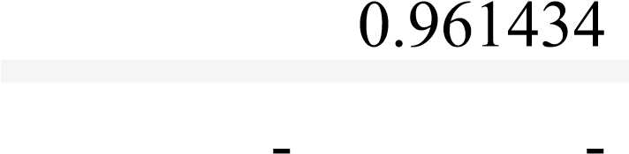 0.328777

0.599927 1.379597

df.index **#-->get all the row names** df.columns type(df) df.dtypes df.info() df.values df.axes df.ndim

df.size

<class 'pandas.core.frame.DataFrame'>

Index: 5 entries, A to E

Data columns (total 4 columns):

# Column Non-Null Count Dtype

--- ------ -------------- -----

1. w 5 non-null float64
2. x 5 non-null float64
3. y 5 non-null float64 3 z 5 non-null float64 dtypes: float64(4) memory usage: 372.0+ bytes

20

**# To access specific column in df** df['w'] type(df['w'])

**#to access multiple columns**

df[['w','x','y']]

# w x y

**A**

-

1.390346

-

0.617943

-

0.235332

**B** 0.776284 -2.006753 -1.595141

**C**

0.044868

-

0.131634

-

0.026057

**D** -1.316303 0.486794 -0.961434

|  |  |
| --- | --- |
| **E** | 0.456750 -1.923114 -0.885952 |

**#to create new column**

df['new'] **=** df['w']**+**df['y'] df

**w x y z new**

|  |  |  |  |  |  |
| --- | --- | --- | --- | --- | --- |
| **A** | -  1.390346 | -  0.617943 | - | 1.834664 | -  1.625679 |

**B** 0.776284 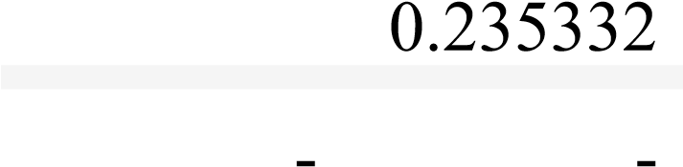 0.525834 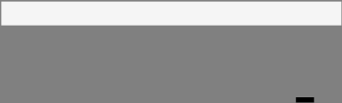

2.006753 1.595141 0.818857

|  |  |  |  |  |
| --- | --- | --- | --- | --- |
| **w** | **x** | **y** | **z** | **new** |
| **C** 0.044868 | -  0.131634 | -  0.026057 | - | 0.018811 |
| -  **D**  1.316303 | 0.486794 | 0.961434 | 1.379597 | -  2.277737 |
| **E** 0.456750 | -  1.923114 | -  0.885952 | 0.328777 | 0.429202 |

**#to remove new column** df.drop('new', axis**=**1, inplace**=True**) df

# w x y z

|  |  |  |  |
| --- | --- | --- | --- |
| **A** |  |  |  |
| **B** |  |  |  |
| **C** |  |  |  |
| **D** -1.316303 | 0.486794 | -0.961434 | -1.379597 |
| **E** 0.456750 | -1.923114 | -0.885952 | 0.328777 |

D.V.LAHARI

22A81A0611